CPE301 – SPRING 2019

MIDTERM 1

Student Name: Saul Alejandro Mendoza Guzman

Student #: 2000540481

Student Email: mendos1@unlv.nevada.edu

Primary Github address: https://github.com/mendos1/subnission_da

Directory: Midterma

Submit the following for all Labs:

1. In the document, for each task submit the modified or included code (only) with highlights and justifications of the modifications. Also, include the comments.
2. Use the previously create a Github repository with a random name (no CPE/301, Lastname, Firstname). Place all labs under the root folder ESD301/Midterm, sub-folder named LABXX, with one document and one video link file for each lab, place modified asm/c files named as LabXX-TYY.asm/c.
3. If multiple asm/c files or other libraries are used, create a folder LabXX-TYY and place these files inside the folder.
4. The folder should have a) Word document (see template), b) source code file(s) and other include files, c) text file with youtube video links (see template).

1. **COMPONENTS LIST AND CONNECTION BLOCK DIAGRAM w/ PINS**
   * Atmega328p Xplained MINI
   * ESP01
   * Jumper cables
   * Atmel Studio 7
   * Breadboard
   * LM34/35
2. **Task Code**

Insert only the modified sections here

#define F_CPU 16000000UL

#define BAUD 9600

#define MYUBRR F_CPU/16/BAUD-1

#include <avr/io.h>

#include <util/delay.h>

#include <stdio.h>

#include <avr/interrupt.h>

#include <stdlib.h>

volatile unsigned int Temperature;

char outs[256]; // OUTPUT ARRAY

volatile char Data_Received;

void usart_send(unsigned char ASCII){ //SEND DATA TO USART

while(!(UCSR0A & (1<<UDRE0 )));

UDR0 = ASCII;

}

unsigned char usart_receive(void){ //RECEIVE DATA

while(!(UCSR0A & (1<< RXC0)));

return Data_Received;

}

void adc_init(void) //INITIALIZE ADC

{

ADMUX = (0<<REFS1)| // REFERENCE SELECTION BITS

(1<<REFS0)| // AVcc - external cap at AREF

(0<<ADLAR)| // ADC Left Adjust Result

(0<<MUX2)| // ANalog Channel Selection Bits

(1<<MUX1)| // ADC2 (PC2 PIN25)

(0<<MUX0); //

ADCSRA = (1<<ADEN)| // ADC ENable

(0<<ADSC)| // ADC Start Conversion

(0<<ADATE)| // ADC Auto Trigger Enable

(0<<ADIF)| // ADC Interrupt Flag

(0<<ADIE)| // ADC Interrupt Enable

(1<<ADPS2)| // ADC Prescaler Select Bits

(0<<ADPS1)| //

(1<<ADPS0); //

TIMSK1 |= (1<<TOIE1); // enable overflow interrupt

TCCR1B |= (1<<CS12)|(1<<CS10); // native clock

TCNT1 = 49911;

}

void read_adc(void) {

unsigned char i =4;

Temperature = 0; // INITIALIZE

while (i--) {

ADCSRA |= (1<<ADSC);

while(ADCSRA & (1<<ADSC));

Temperature+= ADC;

_delay_ms(50);

}

Temperature = Temperature / 8; // SAMPLING

}

/* INIT USART (RS-232) */

void USART_init( unsigned int ubrr ) {

UBRR0H = (unsigned char)(ubrr>>8);

UBRR0L = (unsigned char)ubrr;

UCSR0B |= (1 << TXEN0) | (1 << RXEN0)| ( 1 << RXCIE0); // Enable receiver, transmitter & RX interrupt

UCSR0C |= (1<<UCSZ01) | (1 << UCSZ00);

}

void USART_tx_string( char *data ) {

while ((*data != '\0')) {

while (!(UCSR0A & (1 <<UDRE0)));

UDR0 = *data;

data++;

}

}

int main(void) {

adc_init(); // INITIALIZE THE ADC

USART_init(MYUBRR); // INITIALIZE THE RS232 interface

_delay_ms(500); // WAIT 500ms

sei(); // ENABLE GLOBAL INTERRUPTS

while(1){}

}

ISR(TIMER1_OVF_vect) // TIMER OVERFLOW INTERRUPT TO DELAY

{

char TEMP[256];

unsigned char AT[] = "AT\r\n"; //AT Commands

unsigned char CWMODE[] = "AT+CWMODE=1\r\n"; //Set MODE

unsigned char CWJAP[] = "AT+CWJAP=\"iPXSMax\",\"12345678\"\r\n"; //MUST CHANGE WIFI AND PASSWORD

unsigned char CIPMUX[] = "AT+CIPMUX=0\r\n";

unsigned char CIPSTART[] = "AT+CIPSTART=\"TCP\",\"api.thingspeak.com\",80\r\n";

unsigned char CIPSEND[] = "AT+CIPSEND=100\r\n";

_delay_ms(2000);

USART_tx_string(AT); // SEND COMMANDS

_delay_ms(5000);

USART_tx_string(CWMODE); // SET MODE

_delay_ms(5000);

USART_tx_string(CWJAP); // CONNECT TO WIFI

_delay_ms(15000);

USART_tx_string(CIPMUX); // MUX SELECTION

_delay_ms(10000);

USART_tx_string(CIPSTART);// CONNECT TCP

_delay_ms(10000);

USART_tx_string(CIPSEND);// SEND SIZE

_delay_ms(5000);

PORTC^=(1<<5);

read_adc(); // READ ADC

snprintf(outs,sizeof(outs),"GET https://api.thingspeak.com/update?api_key=Q099IRW0GDEGZYYV&field2=%3d\r\n", Temperature);// print it

USART_tx_string(outs); // SEND DATA

_delay_ms(10000);

TCNT1 = 49911; //reset

}

1. **SCHEMATICS**



1. **SCREENSHOTS OF EACH TASK OUTPUT (ATMEL STUDIO OUTPUT)**

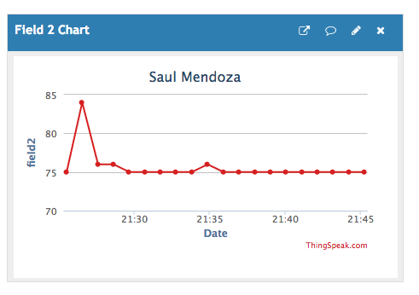

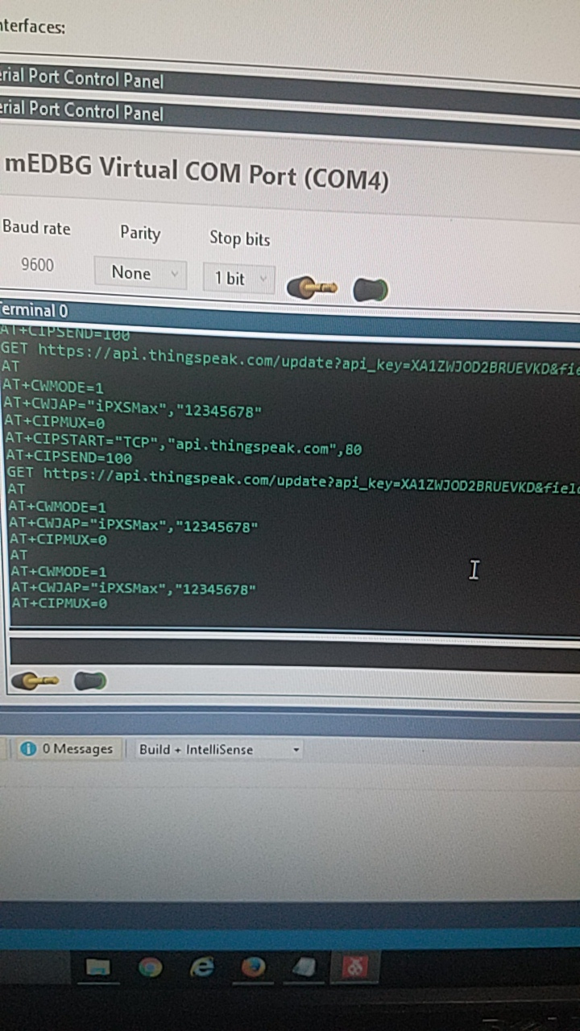

1. **SCREENSHOT OF EACH DEMO (BOARD SETUP)**

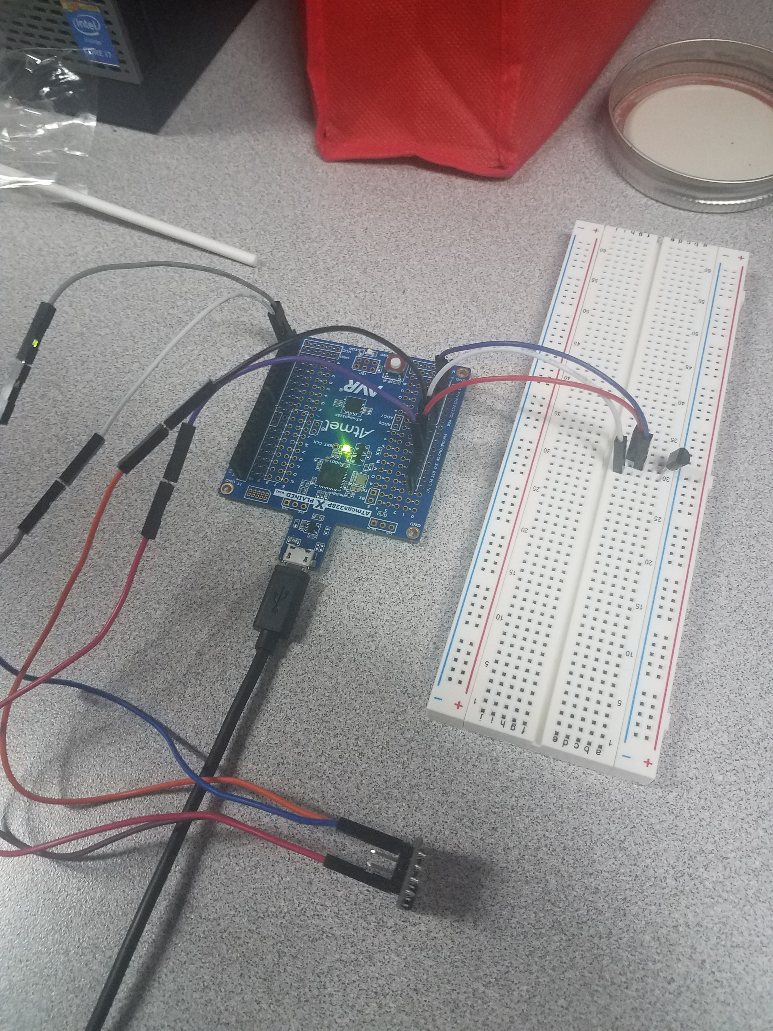

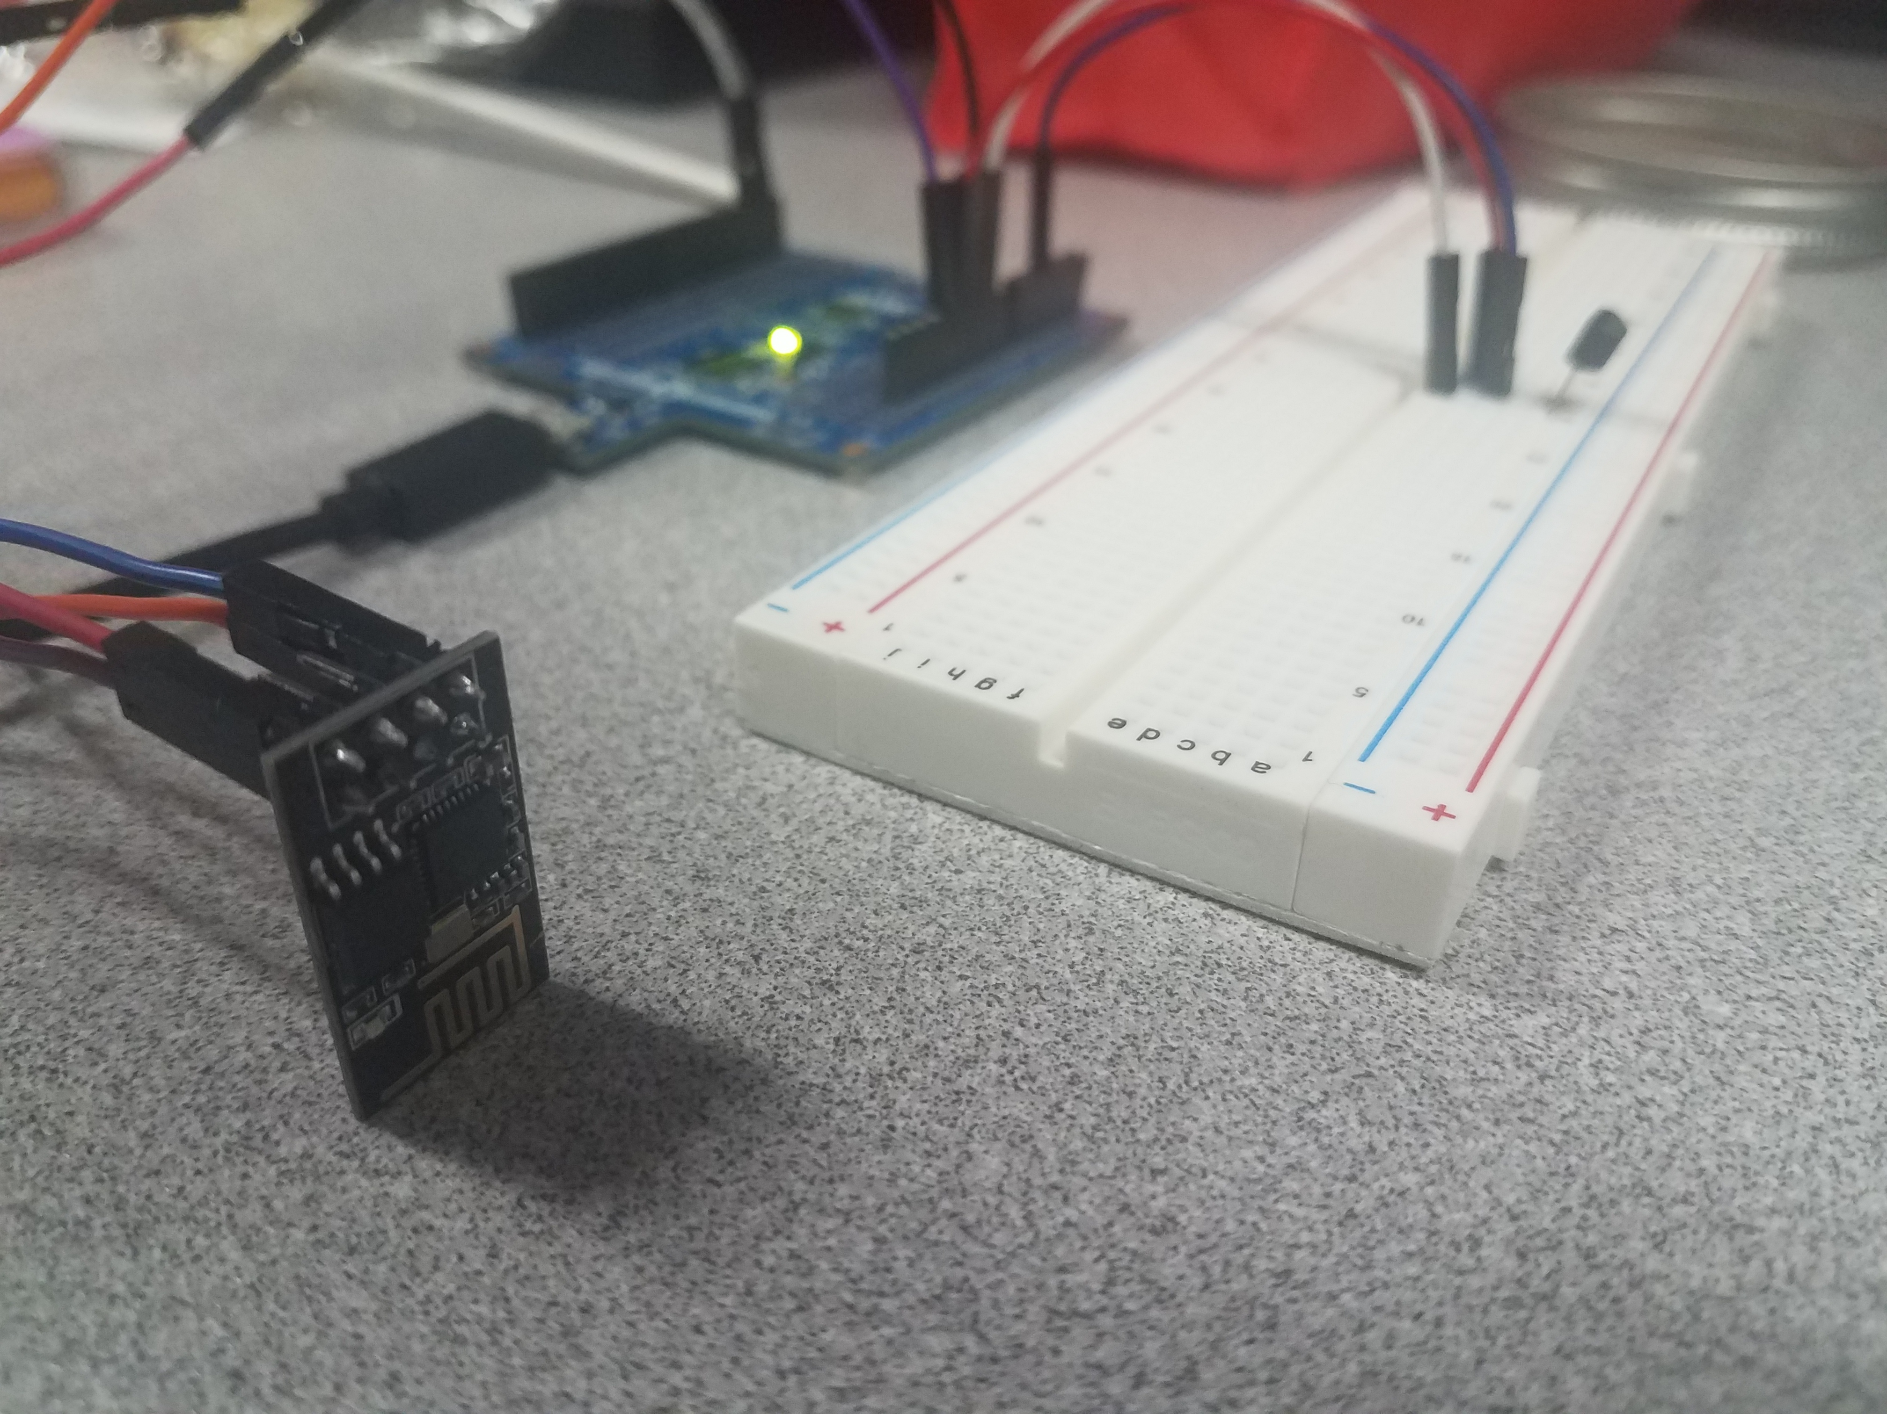

1. **VIDEO LINKS OF EACH DEMO**

<https://www.youtube.com/watch?v=_oty_QQ9yx8>

1. **GITHUB LINK OF THIS DA**

<https://github.com/mendos1/subnission_da>

**Student Academic Misconduct Policy**

<http://studentconduct.unlv.edu/misconduct/policy.html>

“This assignment submission is my own, original work”.

NAME OF THE STUDENT